How Do I Return The Activations On My Pro/Plus License?

如何在我的Pro/Plus许可证上返回激活？

**Symptoms**

* I have used the available activations on my Pro/Plus license
* 我曾在我Pro/Plus许可证上使用了可用的激活
* I would like to activate on a new machine, but have run out of activations
* 我想在新机器上激活，但激活数量已经用完
* I would like to return my old activations
* 我想召回我曾经的激活

**Cause**

Each Unity Pro or Plus license has a set amount of activations. If you wish to activate on a new machine and have already used your allowed activations, you can return the activations to free up the license.

每个Unity Pro或Plus许可证都有一定数量的激活。如果您希望激活一台新的机器并使用您已生效的激活，您可以返回激活以释放许可证

**Resolution**

There are different solutions, depending on your situation.

有几种不同的解决方案，取决与您的情况

***If you do not have access to the machine:***

***如果您无法访问该机器***

If you no longer have access to the machine that your license was activated on, you can return activations made in Unity 4.5 and higher via your Web Store account.

如果您不在有访问您已经激活机器的权限，那么您可以在网页商店的账户中召回在Unity4.5以上版本中进行的激活。

Go [here](https://store.unity3d.com/account/licenses) for licenses purchased before 28th June 2016, otherwise follow these steps:

在2016年6月28日前购买的许可通过此页面，否则参照以下步骤：

1. Sign in [here](https://id.unity.com/).

在这里登录

1. Go to the "My Seats" tab

转到"My Seats"页面

1. Under the "Activation" box, you will see how many activations you have used.

通过"Activation"，您将看到您使用了多少次激活

1. Click the "Remove all my activations" button to clear the license

点击"Remove all my activations"清除许可证

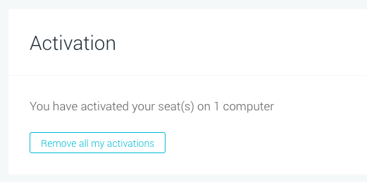

1. The license is now free to be used on different machines.

现在许可证可以自由使用在不同的机器上了

***I have access to the machine:***

***我有访问机器的权限***

If you have access to the machine that the activation is on, users activated in versions higher than Unity 4.5 can users can return their licences within the Editor:

如果您可以访问已经激活的计算机，则Unity4.5以上的激活的用户可以在编辑器中返回其许可证：

1. Open Unity

打开Unity

1. Click “Unity” (or Windows user click “Help”)

点击“Unity”（或Windows用户点击“Help）

1. Click "Manage Licence..."

点击"Manage Licence..."

1. Click "Return Licence"

点击"Return Licence"

This must be done prior to reformatting or a hardware change. You must also have an uninterrupted connection to the license server.

这必须在重新格式化或在硬件修改之前完成，您还必须保证与许可证服务器的链接不能中断。

This does not tend to be the case when behind a proxy, or if you are without Internet connection.

不推荐使用代理，或者您没有网络链接

***3.x license holders:***

***3.x license holders:***

If you are a 3.x license owner, you will need to contact us directly [here](https://support.unity3d.com/hc/en-us/requests/new) and provide your serial number.

如果您是3.x版本的许可证所有者，您需要直接与我们联系饼提供您的序列号

**More Information**

Each **STANDARD** Unity license allows a single person to use Unity on **TWO** machines that they have exclusive use of.

**STANDARD**  Unity许可证允许一个人在两台机器上使用Unity  
  
Each **EDUCATIONAL** Unity license allows a single person to use Unity on **ONE** machines that they have exclusive use of.

**EDUCATIONAL**  Unity许可证允许单人在一台机器上使用Unity

To manage or reassign seats of a license on our website, please see this [article](https://support.unity3d.com/hc/en-us/articles/209019666).

在我们的网站上来管理或重新分配一个许可证的seats，请参见这里